ANEXO IX

CURVAS STC Y NC

TABLA IX.1.- VALORES DE LAS CURVAS STC

(1) | 125 Hz | 250 Hz | 500 Hz | 1.000 Hz | 2.000 Hz | 4.000 Hz
STC 20 | 3 | 12 | 20 | 23 | 24 | 24
STC 21 | 4 | 13 | 21 | 24 | 25 | 25
STC 22 | 5 | 14 | 22 | 25 | 26 | 26
STC 23 | 6 | 15 | 23 | 26 | 27 | 27
STC 24 | 7 | 16 | 24 | 27 | 28 | 28
STC 25 | 8 | 17 | 25 | 28 | 29 | 29
STC 26 | 9 | 18 | 26 | 29 | 30 | 30
STC 27 | 10 | 19 | 27 | 30 | 31 | 31
STC 28 | 11 | 20 | 28 | 31 | 32 | 32
STC 39 | 12 | 21 | 29 | 32 | 33 | 33
STC 30 | 13 | 22 | 30 | 33 | 34 | 34
STC 31 | 14 | 23 | 31 | 34 | 35 | 35
STC 32 | 15 | 24 | 32 | 35 | 36 | 36
STC 33 | 16 | 25 | 33 | 36 | 37 | 37
STC 34 | 17 | 26 | 34 | 37 | 38 | 38
STC 35 | 18 | 27 | 35 | 38 | 39 | 39
STC 36 | 19 | 28 | 36 | 39 | 40 | 40
STC 37 | 20 | 29 | 37 | 40 | 41 | 41
STC 38 | 21 | 30 | 38 | 41 | 42 | 42
STC 39 | 22 | 31 | 39 | 42 | 43 | 43
STC 40 | 23 | 32 | 40 | 43 | 44 | 44
STC 41 | 24 | 33 | 41 | 44 | 45 | 45
STC 42 | 25 | 34 | 42 | 45 | 46 | 46
STC 43 | 26 | 35 | 43 | 46 | 47 | 47
STC 44 | 27 | 36 | 44 | 47 | 48 | 48
STC 45 | 28 | 37 | 45 | 48 | 49 | 49
STC 46 | 29 | 38 | 46 | 49 | 50 | 50
STC 47 | 30 | 39 | 47 | 50 | 51 | 51
STC 48 | 31 | 40 | 48 | 51 | 52 | 52
STC 49 | 32 | 41 | 49 | 52 | 53 | 53
STC 50 | 33 | 42 | 50 | 53 | 54 | 54
STC 51 | 34 | 43 | 51 | 54 | 55 | 55
STC 52 | 35 | 44 | 52 | 55 | 56 | 56
STC 53 | 36 | 45 | 53 | 56 | 57 | 57
STC 54 | 37 | 46 | 54 | 57 | 58 | 58
STC 55 | 38 | 47 | 55 | 58 | 59 | 59
STC 56 | 39 | 48 | 56 | 59 | 60 | 60
STC 57 | 40 | 49 | 57 | 60 | 61 | 61
STC 58 | 41 | 50 | 58 | 61 | 62 | 62
STC 59 | 42 | 51 | 59 | 62 | 63 | 63
STC 60 | 43 | 52 | 60 | 63 | 64 | 64
- Frecuencia central de la banda en Hz, valor de la curva en dBA, valores espectrales en dB.

GRÁFICA IX.2.- CURVAS NC

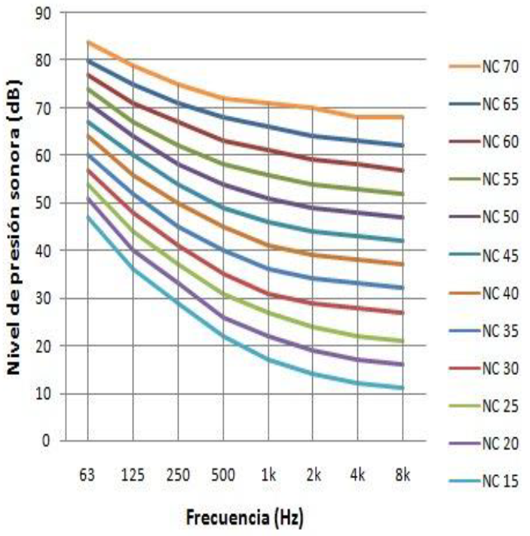

TABLA IX.3.- VALORES DE LAS CURVAS NC (en BO)

(-1) | 63 Hz | 125 Hz | 250 Hz | 500 Hz | 1 KHz | 2 KHz | 4 KHz | 8 KHz
NC-70 | 83 | 79 | 75 | 72 | 71 | 70 | 69 | 68
NC-65 | 80 | 75 | 71 | 68 | 66 | 64 | 63 | 62
NC-60 | 77 | 71 | 67 | 63 | 61 | 59 | 58 | 57
NC-55 | 74 | 67 | 62 | 58 | 56 | 54 | 53 | 52
NC 50 | 71 | 64 | 58 | 54 | 51 | 49 | 48 | 47
NC-45 | 67 | 60 | 54 | 49 | 46 | 44 | 43 | 42
NC-40 | 64 | 57 | 50 | 45 | 41 | 39 | 38 | 37
NC-35 | 60 | 52 | 45 | 40 | 36 | 34 | 33 | 32
NC-30 | 57 | 48 | 41 | 35 | 31 | 29 | 28 | 27
NC-25 | 54 | 44 | 37 | 31 | 27 | 24 | 22 | 21
NC-20 | 51 | 40 | 33 | 26 | 22 | 19 | 17 | 16
NC-15 | 47 | 36 | 29 | 22 | 17 | 14 | 12 | 11
- Frecuencia central de la banda en Hz o KHz, valores espectrales en dB.

